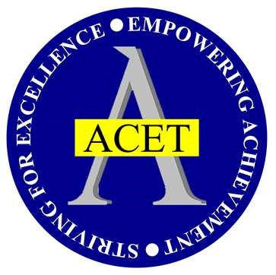

Listerdale Junior Academy

Accessibility Plan
DOCUMENT CONTROL |  | POLICY LEVEL
APPROVED BY | GOVERNING  BOARD | APROVED DATE | DEC 2023
BUSINESS/CURRICULUM LEAD | ASSISTANT  ESTATES  MANAGER/SENDCo | AUTHOR | SARAH  COOPER/HELEN HODGES
NEXT REVIEW DATE | DEC 2026 | FREQUENCY | EVERY 3 YEARS
VERSION NUMBER | DATE ISSUED | UPDATED INFORMATION
V1 | OCTOBER 2020
V2 | Updated SEPT 2024
V3 | Updated Dec 2025 | Minor grammatical changes and updates to dates.

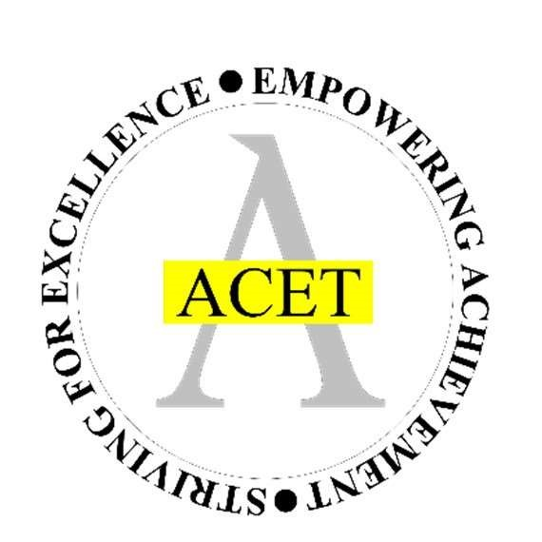
ACET ACCESSIBILITY PLAN
1-year period covered by the plan: 2025-2026

Aston Community Education Trust is committed to providing a fully accessible environment which values and includes all pupils/students, staff, parents and visitors regardless of their education, physical, sensory, social, spiritual, emotional and cultural needs. We are committed to challenging negative attitudes about disability and accessibility and to developing a culture of awareness, tolerance and inclusion.

Definition of Disability
(Equality act 2010)
In the act a person has a disability if:

- they have a physical or mental impairment
- the impairment has a substantial and long-term adverse effect on their ability to perform normal day-to-day activities
For the purposes of the Act, these words have the following meanings:

- 'substantial' means more than minor or trivial
- 'long-term' means that the effect of the impairment has lasted or is likely to last for at least twelve months (there are special rules covering recurring or fluctuating conditions)
- 'Normal day-to-day activities' include everyday things like eating, washing, walking and going shopping

People who have had a disability in the past who meet this definition are also protected by the Act.

Progressive conditions considered to be a disability

There are additional provisions relating to people with progressive conditions. People with HIV, cancer or multiple sclerosis are protected by the Act from the point of diagnosis. People with some visual impairments are automatically deemed to be disabled.

Conditions that are specifically excluded
Some conditions are specifically excluded from being covered by the disability definition, such as a tendency to set fires or addictions to non– prescribed substances.

Aston Community Education Trust (ACET) plans, over time, to increase the accessibility of provision for all pupils/students, staff and visitors to the academy.

The Accessibility Plan will contain relevant actions to:

- Improve access to the physical environment of the academy, adding specialist facilities as necessary
- This covers improvements to the physical environment of the academy and physical aids to access education.

- Increase access to the curriculum for pupils/students with a disability, expanding the curriculum as necessary to ensure that pupils/students with a disability are as equally prepared for life as are the able-bodied pupils/students. This covers teaching and learning and the wider curriculum of the academy such as participation in after-school clubs, leisure and cultural activities or school visits.

- It also covers the provision of specialist aids and equipment, which may assist these pupils/students in accessing the curriculum.

- Improve the delivery of written information to pupils/students, staff, parents and visitors with disabilities. Examples might include handouts, timetables, textbooks and information about the academy and academy events. The information should be made available in various preferred formats within a reasonable time frame.

Action Plans are attached which relate to the three key aspects of accessibility. These plans will be reviewed and adjusted on an annual basis. New Plans will be drawn up every three years.

We acknowledge that it is necessary to raise awareness of issues related to accessibility and to provide training for staff and governors in the matter of disability discrimination.

This Accessibility Plan should be read in conjunction with the Single Equality Policy.
The Accessibility Plan will be published on each academy’s website.
The ACET complaints procedure covers the Accessibility Plan.

Introduction

The SEN and Disability Act 2001 extended the Disability Discrimination Act 1995 (DDA) to cover education. Since September 2002, the Governing Body has had three key duties towards disabled staff and pupils, under Part 4 of the DDA:

- not to treat disabled staff and pupils/students less favourably for a reason related to their disability;
- to make reasonable adjustments for disabled staff and pupils/students, so that they are not at a substantial disadvantage;
- to plan to increase access to education for pupils/students with disabilities.

This plan also takes into account the Equality Act 2010 and needs to be read in conjunction with the Public Sector Equality Duty policy and the SEND Code of Practice 2015.

Definition of disability:

The Disability Discrimination Act (DDA) defines a person with a disability as someone who has ‘a physical or mental impairment which has a substantial and long-term adverse effect on his or her ability to carry out normal day to day activities.’ (Physical or mental impairment includes sensory impairments and also hidden impairments such as: Dyslexia, Autism, Speech & Language impairments, ADHD)
Vision and Values:

- ACET aims to ensure equality of opportunity for all its pupils/students and staff and it follows that pupils/student with disabilities or prospective pupils/students, are not treated less favourably than other pupils/students or prospective pupils/students, for reasons relating to their disability.
- Please read this in conjunction with the SEND Policy.

Information from pupil/student data and academy audit:

The latest information regarding pupils with special educational needs and disability for the academy can be found on the staff intranet.

The main priorities in this plan:

Increasing the extent to which pupils/students with disabilities can participate in the academy’s curriculum:
- The academy will endeavour to provide suitable access to a range of curriculum opportunities.
- Where necessary, support will be given by inclusion, led by the Special Educational Needs Co-ordinator (SENCO).
- The Academy works closely with outside agencies, putting into practice recommendations which are written into the Individual Health Care Plans
- The academy facilitates services from a range of agencies for all pupils/students and their families.

Improving the physical environment of the academy to increase the extent to which pupils/students with disabilities can take advantage of education and associated services:

- Pupils/students and staff with disabilities have access to all learning areas. Ramps are provided to access all buildings to ensure full access for all pupils/students.
- The academy has disabled toilet facilities for pupils/students and staff.
- The academy makes adaptions, such as toilet facilities, steps, stools and taps where required to ensure pupils/students and staff to access the environment and remove barriers.
- The academy has quiet rooms/areas for pupils/staff with sensory differences.
- Classrooms have ‘calm corners’.

Improving the delivery to pupils/students with disabilities of information that is provided in writing for pupils/students who are not disabled:

- Where necessary, all hand-outs, letters, timetables and electronic resources etc. will be made available in suitable format for pupils/students with disabilities.

Improving Physical  Access Target | Action | Outcome | Timescale | Success Criteria | Monitoring/  Review
Ensure no student is excluded from accessing the premises including the academy field and allotment area. | Conduct an annual audit of academy premises taking into account the specific needs of any student either current or prospective. | School premises and classrooms are accessible to all pupils/students | Annual audit and update | All pupils/students can access the curriculum | By Academy  Leaders
Improving Curriculum  Access Target | Action | Outcome | Timescale | Success Criteria | Monitoring/  Review

Ensure that teaching meets the needs of all learners through effective implementation of personalised guidance for pupils/students with specific needs, in keeping with the 2014 SEN Code of Practice which states that: “all children and young people are entitled to an appropriate education, one that is appropriate to their needs, promotes high standards and the fulfilment of potential.” | All teaching staff access and implement in full, the guidance provided  by SENDCO and  Inclusion team relating to pupils/students with specific learning needs,  as set out in the grids  for learning  Whole academy staff CPD will offer all colleagues training and support on accessing and using the grids for learning, and on successful ways to plan, to ensure needs of all pupils are met within lessons  Monitoring of pupils’ timetables to ensure interventions do not restrict the national curriculum offer for these pupils. | All teachers are able to meet the needs of all pupils/students with regard to accessing the curriculum |  | Drop in and lesson observation evidence indicates the needs of all learners are being  met  Training sessions are completed throughout the academic year. | Middle  Leaders / LT/  Principal/  SENDCo

Making it happen
- This plan will be reviewed by governors every 3 years
- This plan should be read in conjunction with other policies such as:
- SEND
- H&S
- Single Equality
- Safeguarding

Accessibility Plan 2025-2026

Ensure consistently high quality in-class support for pupils/students with SEND, meeting the needs of all learners and ensuring implementation of recommendations set out in Individual Health Care Plans and Education  Health and Care Plans | Regularly review the deployment of Teaching  Assistants (TAs)  Review the role of TAs  in the classroom  Access to training for identified needs | Improved attainment and progress for pupils/students with  SEND |  | Learning walk and lesson observation evidence indicates that Teaching Assistants provide consistently high-quality support and that the needs of all pupils/students are being met across the curriculum | Middle  Leaders / LT /  Principal/  SENDCo

Ensure accessibility of laptop provision and any further IT equipment in all lessons for  pupils/students identified as requiring ICT support. | Teacher to ensure arrangements are in  place to facilitate  laptop/IT packages access for all pupils/students requiring ICT support | Improved attainment and progress for pupils/students with  SEND |  | All pupils/students  with  SEND who require ICT support can access the curriculum and achieve. | Class  Teacher
Continue to raise awareness of disability issues and provide  training relating to health conditions such as epilepsy, diabetes and the use of EpiPens. | Provide training and awareness raising sessions in twilights, staff meetings and assemblies for staff and  pupils/students  Provide parents and carers and staff access to network groups and CPD opportunities. | The academy will continue to be a fully inclusive environment |  | Whole academy community is aware of issues relating to access. | By Principal /  Inclusion  Team /  SENDCo
Continue to ensure that the needs of  pupils/students with SEND are met and seen to be met. | Continually review policy and procedures relating to SEND.  Continue to develop and implement support for pupils/students as set out in Individual Health Care Plans, and  Education Health and Care Plans acting on  recommendations from medical and other professionals | Improved attainment and progress for pupils/students with SEND, including those with specific medical needs |  | Needs of  pupils/students with SEND, including those with specific medical needs, are addressed by all teachers  Pupils/students with SEND feel supported.  Data analysis shows progress for pupils/students with SEND in line with expectations and targets. | By Inclusion Manager/  SENDCo

